**Lesson3 APP8:**

**Create an EBS Snapshot**

Creating an EBS snapshot

* Select Volume in EC2 dashboard
* Click on Action -> Create Snapshot

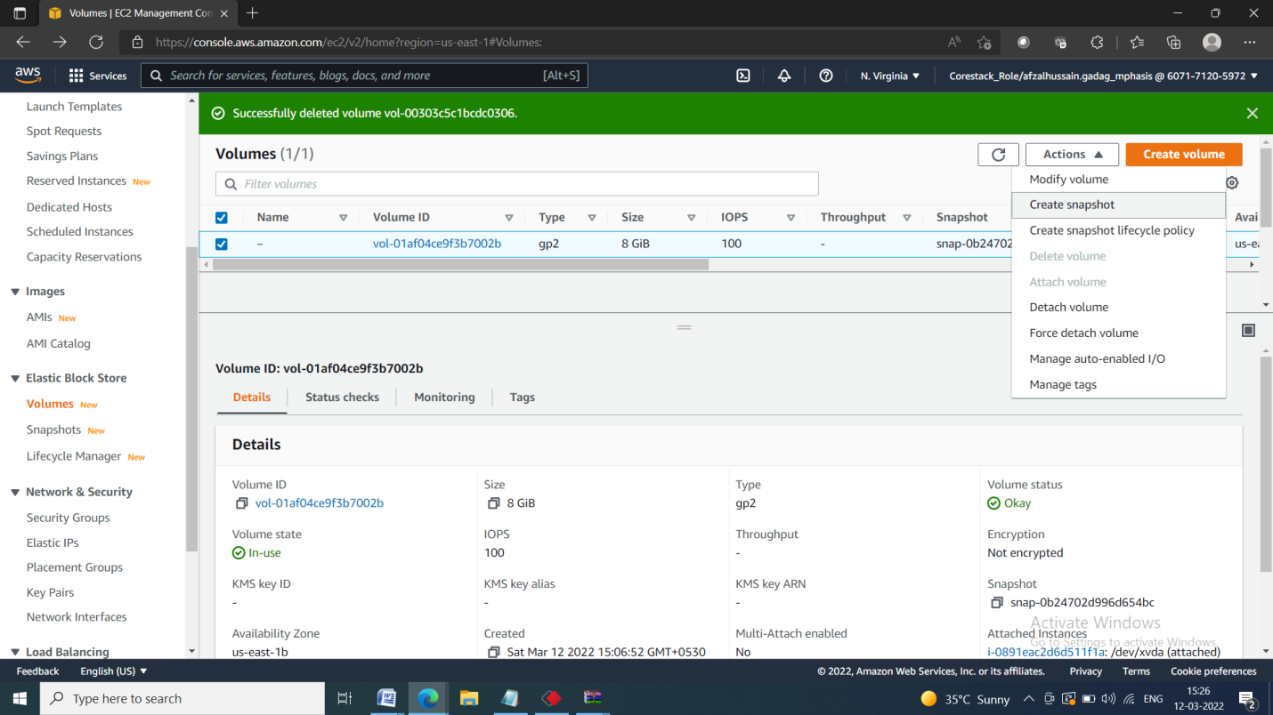

* Add snapshot name, key, and value

